Embedded Systems Orientation  
Exercises Week 7

Fontys ICT  
Version September 2019

This document contains the exercises for week 7. The latest version of this document should be used and it can be downloaded from canvas. Comments on omissions and errors in this document are very welcome and will be incorporated in a new version as soon as possible.

Inhoud

Requirements 1

Display output 1

Control an LED from the PC 2

Background color 3

Elevator Alarm 3

# Requirements

The exercises for this week require the following items:

* Arduino UNO
* USB cable
* Laptop + Arduino IDE
* OPEN-SMART Rich Shield + library

# Display output

Goal: Basic communication from and a PC to an Arduino.

Write a simple windows forms (C#) program that allows you to receive text from Arduino. To do so design a form as follows:

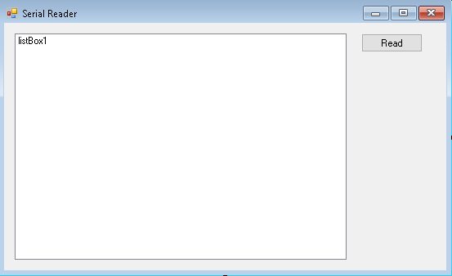

In the windows forms application add a SerialPort to the form and set the correct parameters.

In the Click event handler of the button read the data from the serial port (if data is available)

Write an Arduino program that prints “Hello World.” to the serial port every second.

Now start the windows application. Push the button. You should see the data that Arduino is sending the text.

Extra: instead of using a button you can also use a timer.

# Control an LED from the PC

Write an application that allows you to turn a LED on or off from a Windows forms app.

You application could like like this:

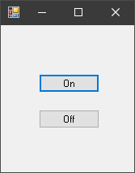

Clicking the “On” switches the red LED on. Clicking the “Off” button switched the red LED off

# Background color

Write an application that allows you to change the background colour of a windows forms app by pressing a button on the Arduino. Key1 makes the background blue and Key2 makes the background Red.

In C# you can use:

BackColor = Color.Blue;

or

BackColor = Color.Red;

To change the window color.

# Elevator Alarm

Write a program that registers alarms in an elevator. The Arduino will be the interface board in the elevator and the windows application will be the system in the control room.

When a user is in distress in an elevator, they can push the alarm key (KEY1). Upon pressing the alarm key, A red LED lights up and a signal is sent to the control room. When the control room staff see the alarm on their app they will push the “Respond” button in their app. This indicates that they have received the alarm. When respond is pushed the buzzer sounds briefly and the green LED lights up in the elevator.

When the situation is solved the staff in the control room will push the “Clear” button to reset the alarms. All LEDs in the elevator turn off and the system resets back to normal.

The control room application could look like this:

Normal state:

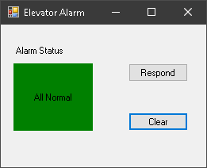

Alarm State:

